1. So, we will be doing initial deployment. For that reason, we need to setup the serverless env with necessary packages as below

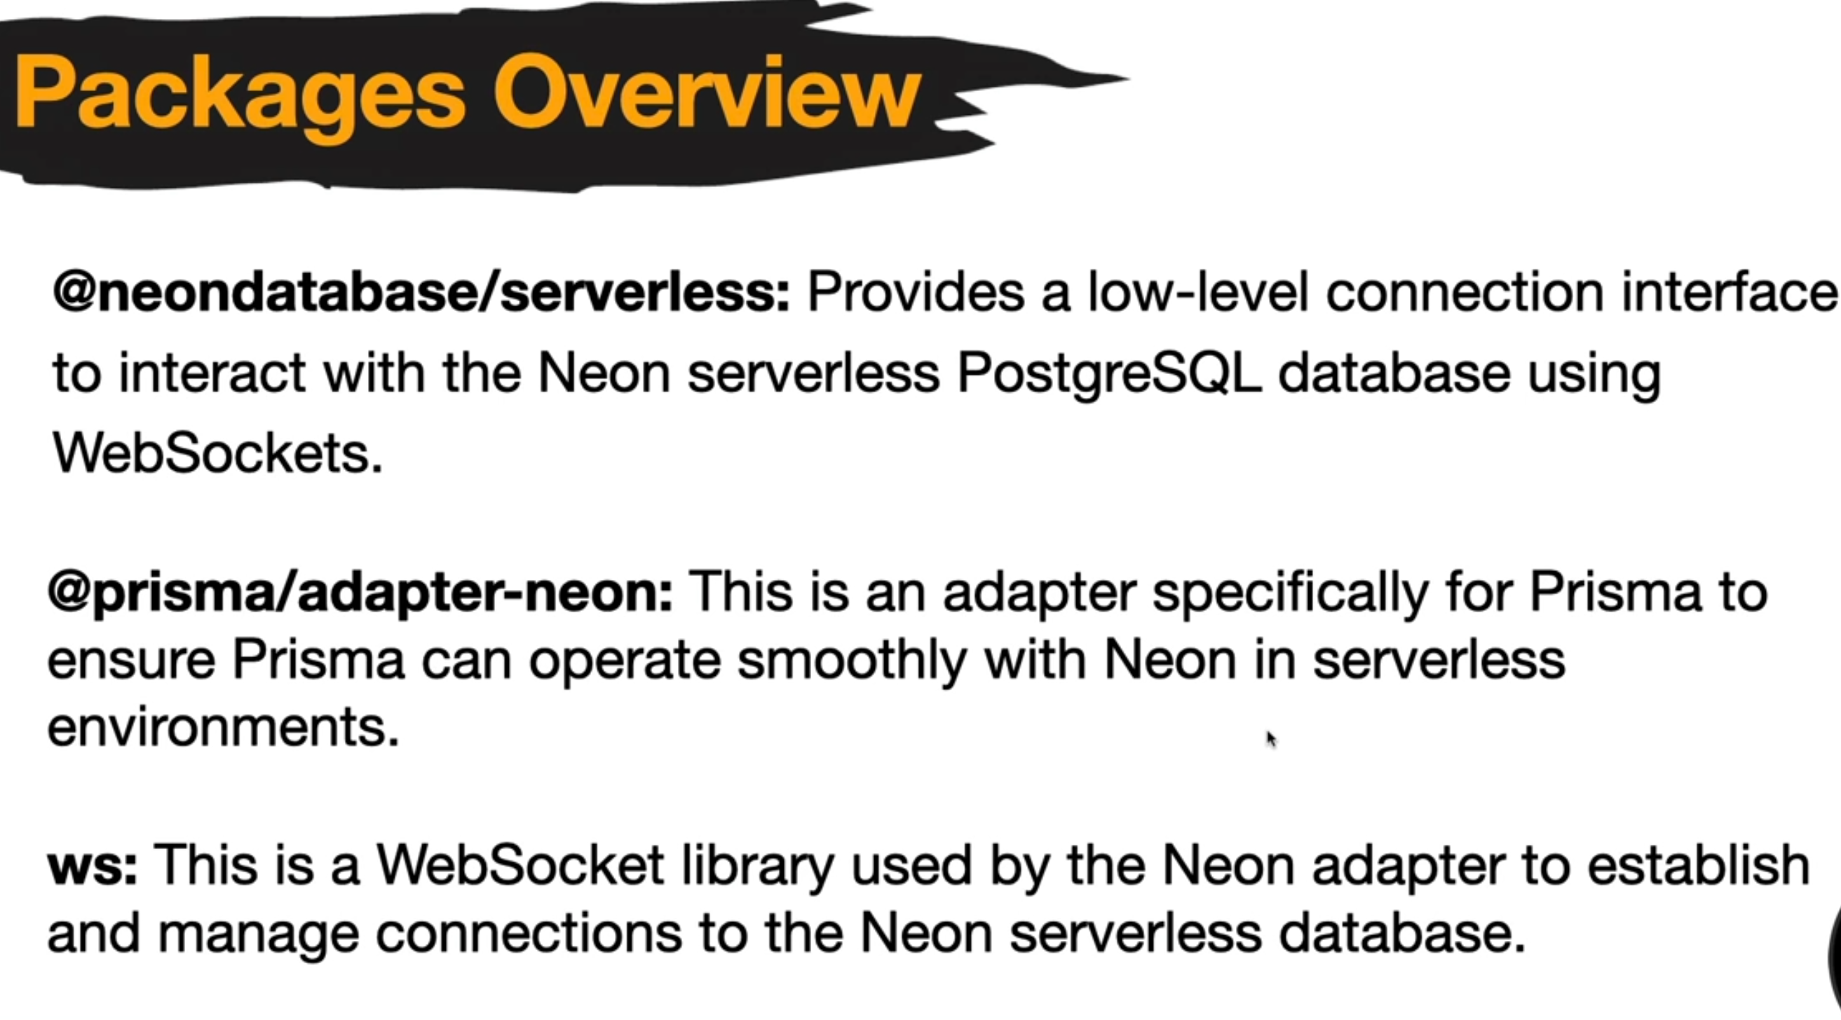

* We will install those



* Then also some dev dependencies that are needed



1. To use the adapter, we need to add this line of code

1. Now, we added a new code for the config, but kept getting an error showing

1. But that was occurring because we were using old config methods by importing pool. Below is the working method

1. Now we use this Prisma in all the other files

1. We then run the command to create client, delete the next cache folder and run the server and everything should work just fine.





